Celebration Lutheran Church
Pastor: Sarah Toney Preacher: Rev. Liv Larson Pianist: Susan Gubsch
3rd Sunday in Easter April 19, 2026

Welcome to Easter Morning!

Prelude Music
Welcome and Announcements

We Gather to Encounter God

Gathering Hymn: Christ the Lord is Risen Today # 369

Thanksgiving for Baptism
L: Alleluia! Christ is risen.
C: Christ is risen indeed. Alleluia!
L: Salvation belongs to our God who is seated on the throne
and to the Lamb!
C: Amen.

L: Let us give thanks for the gifts of baptism. Merciful God,
you are the one who was, who is, and who is to come. You lead us beside still waters. We thank you for the waters of creation: morning dew, gentle rain, roaring waves. We thank you for the waters that nourish us, especially the Columbia River. Blessed are you.
C: You guide us to springs of the water of life.

L: Jesus Christ, you are the faithful witness who accompanies us on our journeys. We give you thanks for your life-giving death and resurrection. We praise you for joining us in joy and sorrow. Blessed are you.
C: You guide us to springs of the water of life.

L: Holy Spirit, you anoint our head with oil and our cup overflows.
Break down barriers that divide us. Fill us with the breath of peace.
Blessed are you.
C: You guide us to springs of the water of life.

L: Holy One, we thank you for the gifts and grace of baptism, and for making us a new creation. We join with saints and angels, giving you honor and praise, now and forever.
C: Amen.

2
We Pray in Song: Kyrie pg. 175
3
Gloria pg. 176
Prayer of the Day
L: O God,
C: … your Son makes himself known to all his disciples in the breaking of bread. Open the eyes of our faith, that we may see him in his redeeming work, who lives and reigns with you and the Holy Spirit, one God, now and forever. Amen.

We Hear God’s Word

First Reading: Acts 2:14a, 36-41
^{14a} Peter, standing with the eleven, raised his voice and addressed [the crowd]: ³⁶ “Therefore let the entire house of Israel know with certainty that God has made him both Lord and Messiah, this Jesus whom you crucified.”

4
³⁷ Now when they heard this, they were cut to the heart and said to Peter and to the other apostles, “Brothers, what should we do?” ³⁸ Peter said to them, “Repent and be baptized every one of you in the name of Jesus Christ so that your sins may be forgiven, and you will receive the gift of the Holy Spirit. ³⁹ For the promise is for you, for your children, and for all who are far away, everyone whom the Lord our God calls to him.” ⁴⁰ And he testified with many other arguments and exhorted them, saying, “Save yourselves from this corrupt generation.” ⁴¹ So those who welcomed his message were baptized, and that day about three thousand persons were added.

Psalm 34:1-10
¹ I will bless the Lord at all times;
the praise of God shall ever be in my mouth.
² I will glory in the Lord;
let the lowly hear and rejoice.
³ Proclaim with me the greatness of the Lord;
let us exalt God's name together.
⁴ I sought the Lord, who answered me
and delivered me from all my terrors.
⁵ Look upon the Lord and be radiant,
and let not your faces be ashamed.
⁶ I called in my affliction, and the Lord heard me
and saved me from all my troubles.
⁷ The angel of the Lord encamps around those who fear the Lord
and delivers them.
⁸ Taste and see that the Lord is good;
happy are they who take refuge in God!
⁹ Fear the Lord, you saints of the Lord,
for those who fear the Lord lack nothing.
¹⁰ The lions are in want and suffer hunger,
but those who seek the Lord lack nothing that is good

Second Reading: 1 Peter 1:17-23
¹⁷ If you invoke as Father the one who judges impartially according to each person’s work, live in fear during the time of your exile. ¹⁸ You know that you were ransomed from the futile conduct inherited from your ancestors, not with perishable things like silver or gold ¹⁹ but with the precious blood of Christ, like that of a lamb without defect or blemish. ²⁰ He was destined before the foundation of the world but was revealed at the end of the ages for your sake. ²¹ Through him you have come to trust in God, who raised him from the dead and gave him glory, so that your trust and hope are in God.
²² Now that you have purified your souls by your obedience to the truth so that you have genuine mutual affection, love one another deeply from the heart. ²³ You have been born anew, not of perishable but of imperishable seed, through the living and enduring word of God.

Gospel Hymn: Alleluia pg. 179

6
Holy Gospel: Luke 24:13-35
L: The holy gospel according to St. Luke in the 24th chapter.
C: Glory to you, O Lord.

¹³ Now on that same day two [disciples] were going to a village called Emmaus, about seven miles from Jerusalem, ¹⁴ and talking with each other about all these things that had happened. ¹⁵ While they were talking and discussing, Jesus himself came near and went with them, ¹⁶ but their eyes were kept from recognizing him. ¹⁷ And he said to them, “What are you discussing with each other while you walk along?” They stood still, looking sad. ¹⁸ Then one of them, whose name was Cleopas, answered him, “Are you the only stranger in Jerusalem who does not know the things that have taken place there in these days?” ¹⁹ He asked them, “What things?” They replied, “The things about Jesus of Nazareth, who was a prophet mighty in deed and word before God and all the people, ²⁰ and how our chief priests and leaders handed him over to be condemned to death and crucified him. ²¹ But we had hoped that he was the one to redeem Israel. Yes, and besides all this, it is now the third day since these things took place. ²² Moreover, some women of our group astounded us. They were at the tomb early this morning, ²³ and when they did not find his body there they came back and told us that they had indeed seen a vision of angels who said that he was alive. ²⁴ Some of those who were with us went to the tomb and found it just as the women had said, but they did not see him.” ²⁵ Then he said to them, “Oh, how foolish you are and how slow of heart to believe all that the prophets have declared! ²⁶ Was it not necessary that the Messiah should suffer these things and then enter into his glory?” ²⁷ Then beginning with Moses and all the prophets, he interpreted to them the things about himself in all the scriptures.
²⁸ As they came near the village to which they were going, he walked ahead as if he were going on. ²⁹ But they urged him strongly, saying, “Stay with us, because it is almost evening and the day is now nearly over.” So he went in to stay with them. ³⁰ When he was at the table with them, he took bread, blessed and broke it, and gave it to them.
7
³¹ Then their eyes were opened, and they recognized him, and he vanished from their sight. ³² They said to each other, “Were not our hearts burning within us while he was talking to us on the road, while he was opening the scriptures to us?” ³³ That same hour they got up and returned to Jerusalem, and they found the eleven and their companions gathered together. ³⁴ They were saying, “The Lord has risen indeed, and he has appeared to Simon!” ³⁵ Then they told what had happened on the road and how he had been made known to them in the breaking of the bread.

L: The gospel of our Lord.
C: Praise to you, O Christ.

Sermon

We Respond to God’s Word

Hymn of the Day: Loaves Were Broken ACS # 966
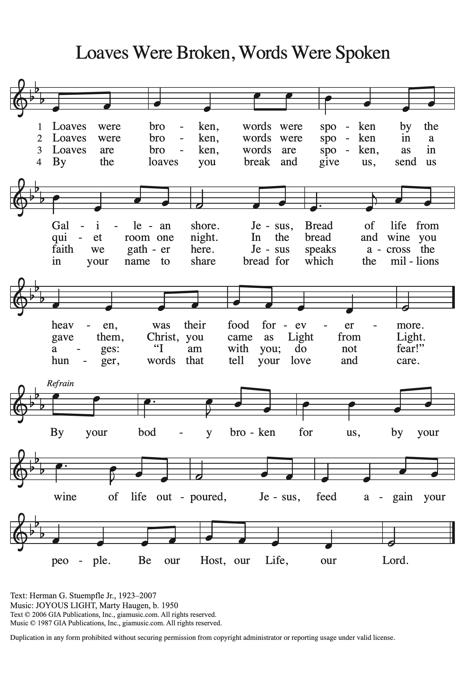
8
Blessing of the Quilts
L: God, our neighbors around the world are in need of hope.
Your Spirit is a mighty force, your whispers of hope bring
light into the world. Open our hearts and hands to see your
presence in our neighborhoods and across the world.
C: Jesus, help us speak words of hope to our neighbors.

L: God, we give you thanks for the pieces of fabric, thread,
sewing machines, and the items collected for the kits. May
their presence be a sign of hope, may these quilts wrap our
neighbors in unending love, and may these kits offer dignity
and healing.
C: Jesus, help us reach out in hope to our neighbors.

L: God, we give thanks for all the hands that fashioned hope
into a quilt, for the hands that collected and sorted, for the
hands that continually open wider so that no one feels left
out.
C: Jesus, help us see hope in our neighbors.
L: God, we ask you to guide the staff and partners at LWR.
May their voices and hands be a beacon of hope. Keep them
safe. Keep them filled with your strength and perseverance.
C: Jesus, help us share a taste of hope with our neighbors.

L: God, be with our neighbors who will receive these gifts.
May they be wrapped in love, may they taste your goodness,
may they touch signs of your hope. Whether or not we know
their names or where they live, they are our neighbors, our
brothers and sisters in Christ. We pray all this in the name of
Jesus, the One who is our hope.
C: Amen.

9
Greeting of Peace
L: The peace of the Lord be with you always.
C: And also with you.

We Offer Our Gifts

Offertory Hymn: God Extends and Invitation # 486
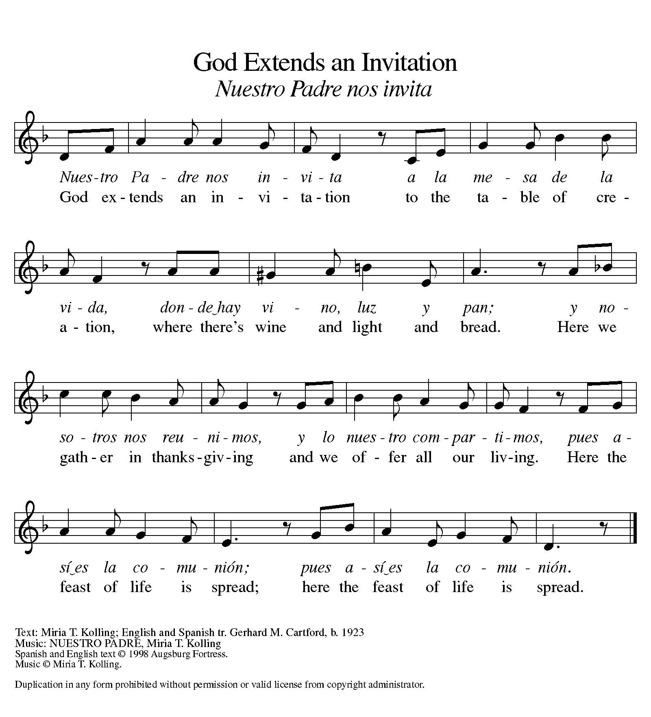

Prayer of Thanksgiving
L: Merciful God,
C: … accept the fruits of our labor, gathered to give you glory. You have set a table before us, a glimpse of that great day when we will hunger and thirst no more. Nourish us with the body and blood of Jesus, that goodness and mercy may follow us and bless the world you love. In the name of Jesus, Amen.

We Share Christ’s Meal

10
The Great Thanksgiving
L: The Lord be with you C: And also with you
L: Lift up your hearts C: We lift them to the Lord
L: Let us give thanks to the Lord our God
C: It is right to give our thanks and praise.

Communion Prayers and the Story of Our Lord's Supper

The Lord's Prayer
L: Gathered into one by the Holy Spirit, let us pray as Jesus taught us.
C: Our Father, who art in heaven, hallowed be thy name, thy kingdom come, thy will be done on earth as it is in heaven. Give us this day our daily bread; and forgive us our trespasses, as we forgive those who trespass against us; and lead us not into temptation, but deliver us from evil. For thine is the kingdom, and the power, and the glory, forever and ever. Amen.

11
Communion Hymns: O Lamb of God pg. 182
Holy, Holy, Holy # 473
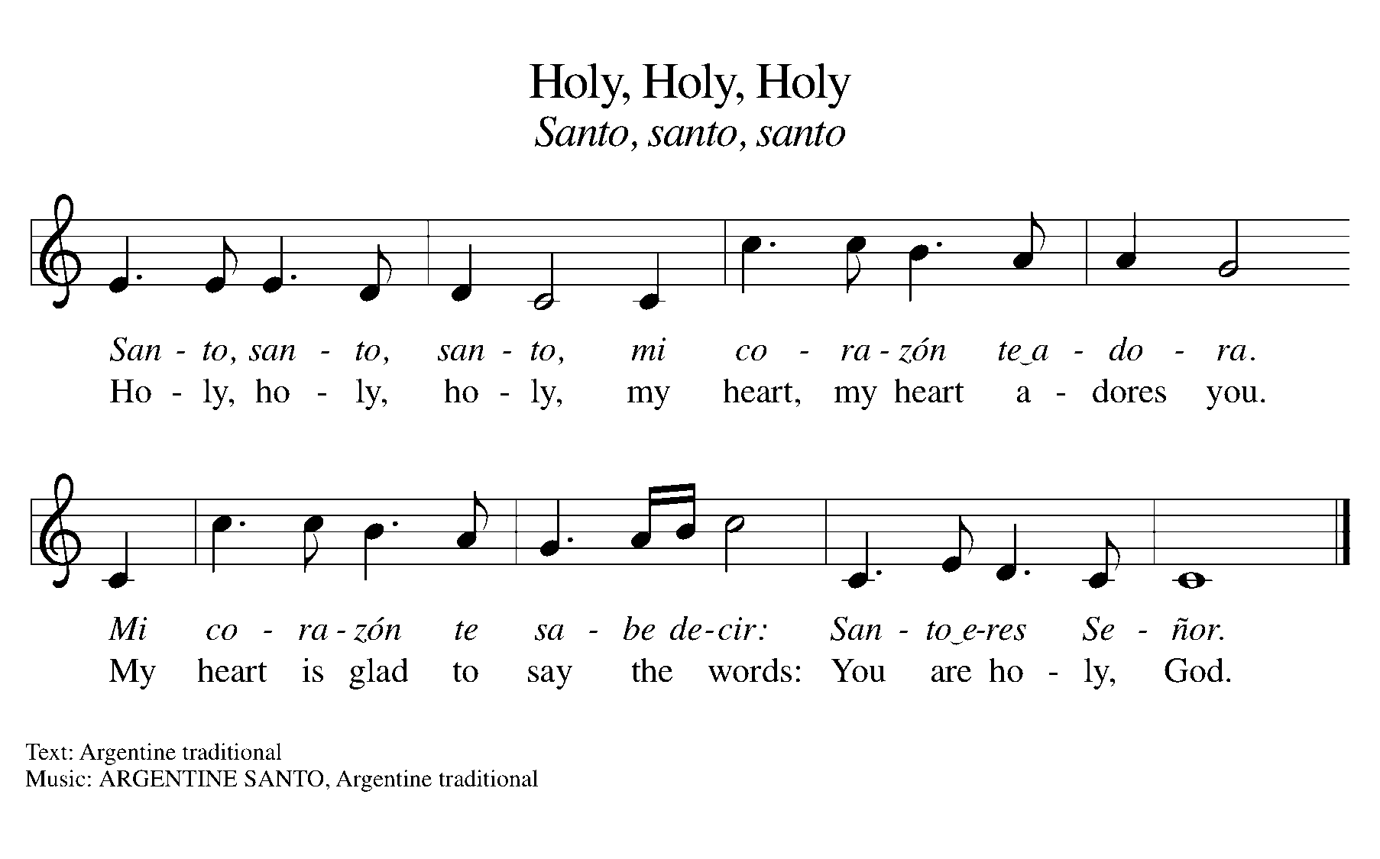

12
Post-Communion Prayer & Blessing

Sending Hymn: That Easter Day with Joy Was Bright # 384
Dismissal
L: Go in peace. Praise the Lord. Alleluia!
C: Thanks be to God. Alleluia!

We Go To Love Others As Christ Loves Us!
All rights reserved. Reprinted under ONE LICENSE #A-727265

